Contact

TC_101

Ensure that the email, phone numbers, and alternative number are displayed correctly

1.Open the Contact Us page  
  
2.Verify the email address is displayed correctly  
  
3.Verify the primary mobile number is displayed correctly  
  
4.Verify the alternative mobile number is displayed correctly

mobile number and alternative number are same

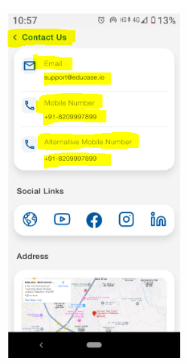

TC_102

Ensure that tapping on the email link opens the email client

1.Tap on the email address link  
  
2.Check if the default email client opens  
  
3.Verify the "To" field is auto-filled with the email address

Working as expected

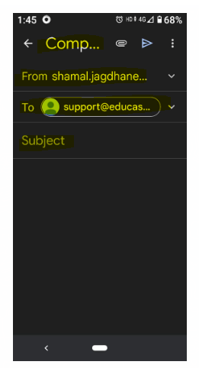

TC_103

Ensure that tapping on the phone number opens the dialer

1.Tap on the mobile number  
  
2.Verify the phone dialer opens with the number auto-filled  
  
3.Check if the user can initiate a call

Working as expected

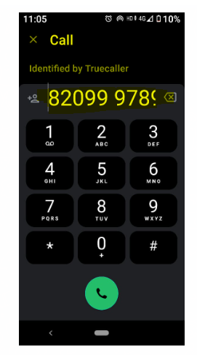

TC_104

Ensure that all social media icons are functional

1.Click on each social media icon (YouTube, Facebook, Instagram, LinkedIn)  
  
2.Verify the correct app or website opens in a browser  
  
3.Check if it redirects to the correct organization profile

Working as expected

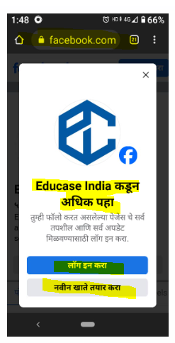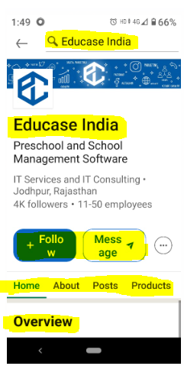

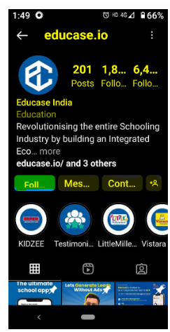

TC_105

Ensure that the address map link shows address correctly

1.Click on the map preview  
  
2.Verify Google Maps opens  
  
3.Check if the correct location is displayed

Working as expected

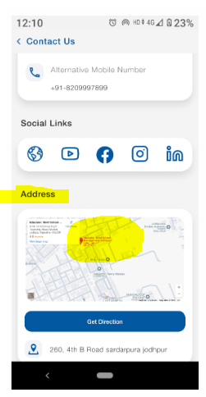

TC_106

Ensure the UI elements are properly aligned and readable

1.Open the Contact Us page  
  
2.Verify text alignment and font size  
  
3.Check the visibility of icons and links  
  
Ensure no overlapping or broken elements

Working as expected

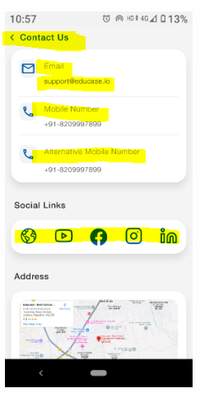

TC_107

Ensure that incorrectly formatted phone numbers are not displayed

1.Open the Contact Us page  
  
2.Verify that the phone number follows the correct format (+91-XXXXXXXXXX)  
  
3.Check for missing digits or incorrect characters

Working as expected

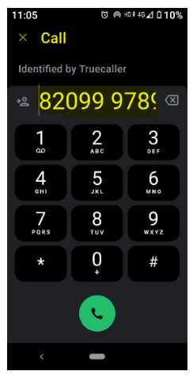

TC_108

Ensure the Contact Us page is correctly displayed in dark mode

1.Enable dark mode on the device  
  
2.Open the Contact Us page  
  
3.Check if all text and UI elements are properly visible and readable

Working as expected



TC_109

Ensure the Contact Us page is responsive on different screen sizes

1.Open the app on multiple devices (small, medium, large screens)  
  
2.Verify the alignment and visibility of all UI elements  
  
3.Check if elements adjust properly to screen size

The UI should adjust properly, without misalignment or overlapping

TC_110

Ensure the system does not accept special characters in phone number input

1.Navigate to the Contact Us page  
  
2.Enter +91-82@#99978**99  
  
3.Submit the form (if applicable)  
  
4.Observe system behavior

The system should reject special characters in phone numbers

TC_111

Verify that an incorrect email format displays an appropriate error message

1.Navigate to the Contact Us page  
  
2.Enter an email without @ or domain (e.g., testuser.com)  
  
3.Observe the validation message

Working as expected

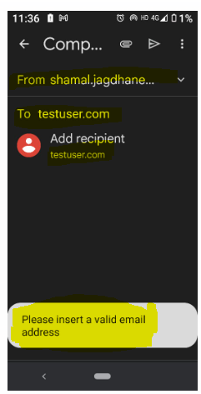

TC_112

Verify Email with valid data

1. Navigate to Contact Us page

2. Enter valid email

3. Submit form

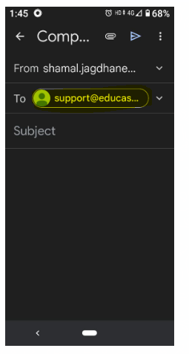

TC_113

Verify social media links

1. Click on each social media icon

2. Verify redirection

Working as expected





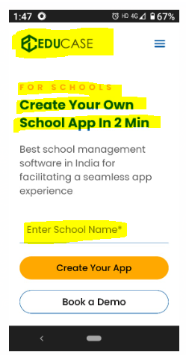

TC_114

Verify map functionality

1. Click on "Get Directions"

2. Check if map opens correctly

Clicking the map is not opening Google Maps with the correct location

